To 2nd March 2021,

**North Town Estate Pvt. Ltd.,**

**Site : Perambur,**

**Chennai.**

Ref: CEPL/20-21/094-R1

Dear Sir,

Sub: **Quote for Waterproofing, Grouting Expansion Joint Treatment & Polysulphate Sealant.**

We thank you for your enquiry. With reference to the discussion had by the undersigned with yourself, please find the quotation for following items.

|  |  |  |  |  |  |
| --- | --- | --- | --- | --- | --- |
| **SR.NO.** | **DESCRIPTION** | **UNIT** | **QTY** | **RATE** | **AMOUNT** |
| 1 | Providing and Laying Waterproofing Treatment by applying two coats of **Brushbond TGP**  over the prepared surface after floor and wall coving with Nitobond SBR admixed with C.M 1:3 and protecting the same with **120GSM Geo Textile Membrane** as per manufacture specification | Sqmtr | 2100.00 | 480.00 | 10,08,000.00 |
| 2 | Charges for Grouting of Nipples at Construction Joints with cement slurry admixed with **Fosroc Cebex 100** as per manufacture specification. | Nos | 300.00 | 450.00 | 1,35,000.00 |
| 3 | Charges for Supply and Application **of Pronil Porseal - 1mm Thk X 150 mm Width** with epoxy adhesive after preparation of surface by filling the expansion joint with polysulphate sealant and covering the same with **Aluminum Sheet of 1mm** Thick as per engineer incharge. | Rmtrs | 400.00 | 2100.00 | 8,40,000.00 |
| 4 | Charges for Supply and Application **of Pronil Porseal - 1mm Thk X 150 mm Width** after preparation of surface and application of epoxy adhesive and covering the same with **Aluminum Sheet of 5mm Thick** as per engineer incharge. | Rmtrs | 400.00 | 2350.00 | 9,40,000.00 |

**GST @ 18 % Extra**

**Terms & Conditions:**

1. Work shall be commenced immediately on receipt of work order.
2. **Payment:** We require 50 % of order value as advance along with the order and the balance payment against running bills.
3. Water, Electricity, Cement and Sand required for Treatment shall be provided by the contractor at free of cost.
4. **Godown**  facility for storing our materials shall be provided by the client.

Thanking You,

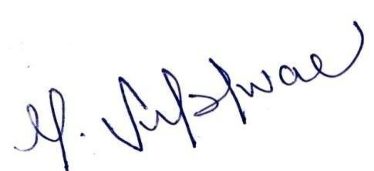Yours faithfully,

**For Civitech Engineering Private Limited**

**Subishwar Murali**

**Executive Director**