To 09th February 2021,

**Hotel Benz Park,**

**Site : T.Nagar,**

**Chennai**

Ref: CEPL/20-21/078

Dear Sir,

Sub: **Quote for Waterproofing - Basement**

We thank you for your enquiry. With reference to the discussion had by the undersigned with yourself, please find the quotation for Terrace Waterproofing – Common Wall – Reg.

|  |  |  |  |  |  |
| --- | --- | --- | --- | --- | --- |
| **SR.NO.** | **DESCRIPTION** | **UNIT** | **QTY** | **RATE** | **AMOUNT** |
| 1 | **WATERPROOFING** – Charges for Chipping the existing the tiles and removing the filling BJC and Providing Waterproofing Treatment applying two coats of **Pidifin 2K** over the prepared surface of floor and wall joint coving with C.M 1: 3 admixed with **Pidicrete URP** and plastering the same with Conplast WL. |  |  |  |  |
|  | **Basement -1 Pump Room 1111** | Sqft | 1400.00 | 45.00 | 63,000.00 |
|  | **Adjacent Ramp Connection Slab** | Sqft | 1100.00 | 45.00 | 49,500.00 |
| 2 | Charges for Grouting of Nipples at Construction Joints with cement slurry admixed with Fosroc Cebex 100 as per manufacture specification. | Nos | 35.00 | 400.00 | 14,000.00 |
|  | SUB-TOTAL |  |  |  | 1,26,500.00 |
|  | GST @ 18% |  |  |  | 22,770.00 |
|  | **TOTAL AMOUNT** |  |  |  | **1,49,270.00** |

**Terms & Conditions:**

1. Work shall be commenced one week on receipt of work order.
2. **Payment:** We require 50 % of order value as advance along with the order and the balance payment against running bills.
3. Water and Electricity required for Treatment shall be provided by the contractor at free of cost.
4. **Godown**  facility for storing our materials shall be provided by the client.

Thanking You,

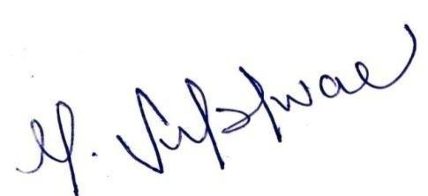Yours faithfully,

**For Civitech Engineering Private Limited**

**Subishwar Murali**

**Executive Director**