To 06th March 2021,

**SRM COLLEGE,**

**Site: Potheri,**

**Chennai**

Ref: CEPL/20-21/095

Dear Sir,

Sub: **Quote for Flooring Work**

We thank you for your enquiry. With reference to the discussion had by the undersigned with yourself, please find the quotation for following items.

|  |  |  |  |  |  |
| --- | --- | --- | --- | --- | --- |
| **SR.NO.** | **DESCRIPTION** | **UNIT** | **QTY** | **RATE** | **AMOUNT** |
| 1 | Charges for Providing of Cement Concrete 1:11/2:3 by volume for average thickness of 6”. | Sqft | 1700.00 | 80.00 | 1,36,000.00 |
| 2 | Charges for Laying Cement Concrete and finishing it with Power Trowel as per specification and direction of engineer in charge. | Sqft | 1700.00 | 25.00 | 42,500.00 |
| 3 | Charges for Supply and Application of APP Membrane of 3mm Thk and application using torch as per manufacture specification. | Sqft | 300.00 | 75.00 | 22,500.00 |
| 4 | Charges for Laying Brickwork 4” with C.M 1: 4 and plastering the same with Cement and Mortar as per site in engineer in charge. | Sqft | 200.00 | 157.00 | 31,400.00 |
| 5 | Charges for Laying Metal Roof JSW will all necessary supports complete. | Sqft | 100.00 | 200.00 | 20,000.00 |
|  | SUB-TOTAL |  |  |  | 2,52,400.00 |
|  | GST @ 18% |  |  |  | 45,432.00 |
|  | **TOTAL incl. of taxes** |  |  |  | **2,97,832.00** |

**Terms & Conditions:**

1. Work shall be commenced immediately on receipt of work order.
2. **Payment:** We require 50 % of order value as advance along with the order and the balance payment against running bills.
3. Water and Electricity required for Treatment shall be provided by the contractor at free of cost.
4. **Godown**  facility for storing our materials shall be provided by the client.

Thanking You,

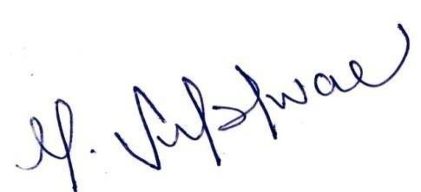Yours faithfully,

**For Civitech Engineering Private Limited**

**Subishwar Murali**

**Executive Director**